# Nested loop and pattern in C++

Task 01:

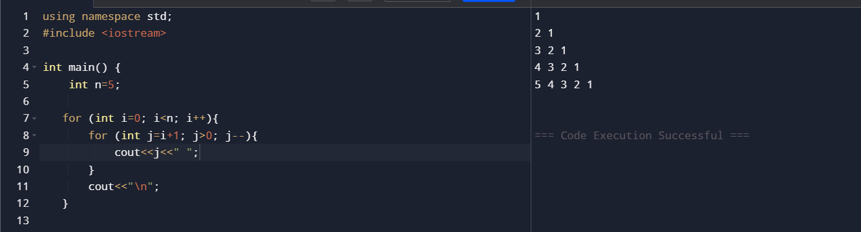

Task 02:

Task 03:

Task 04:

Task 05:

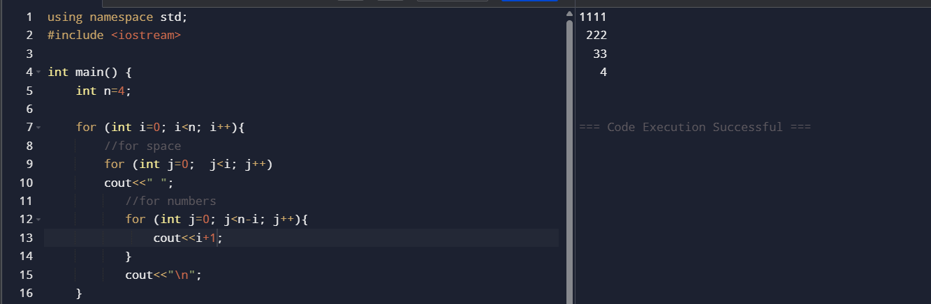

Task 06:

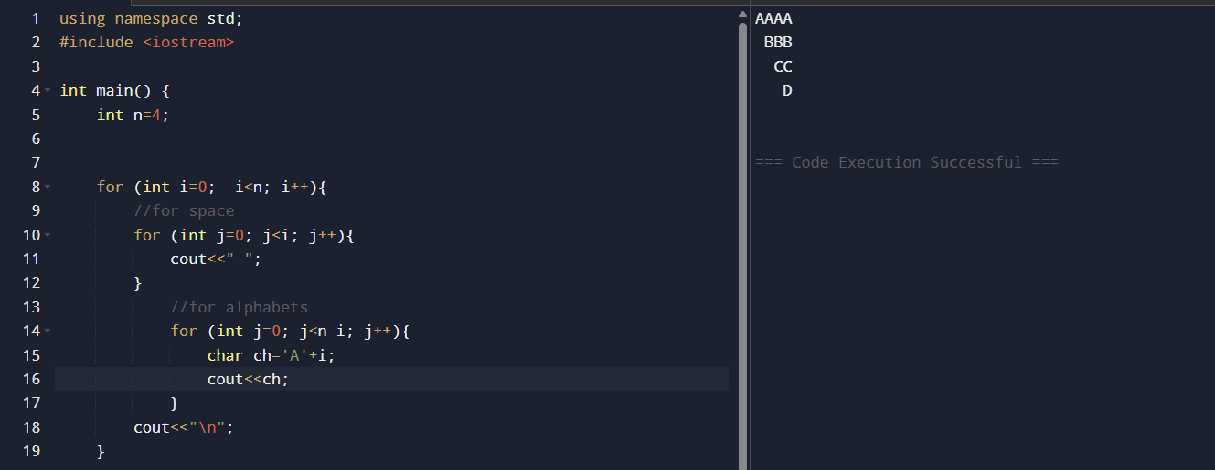

Task 07:

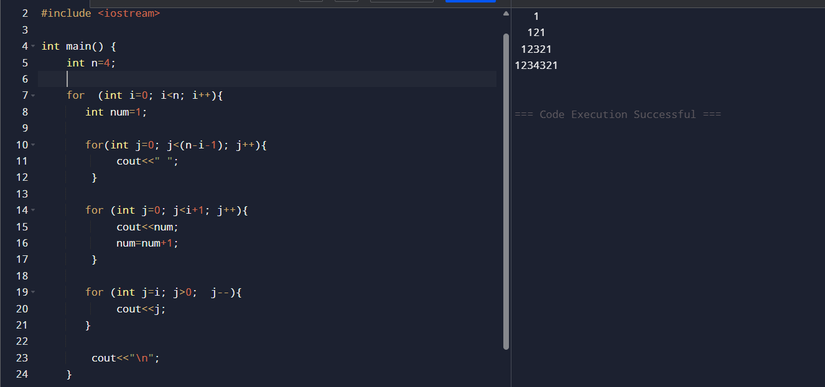

Task 08:

